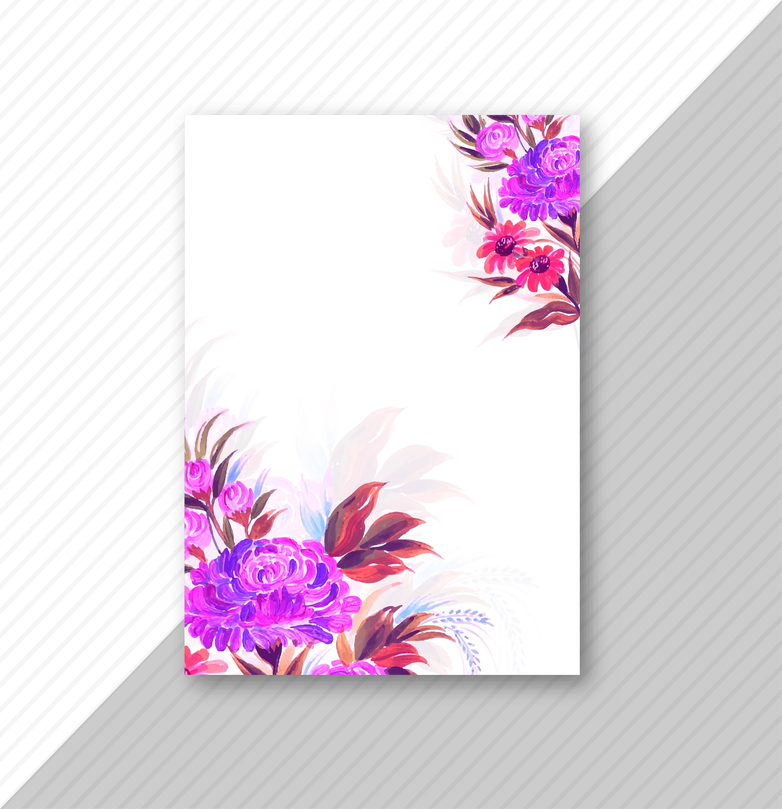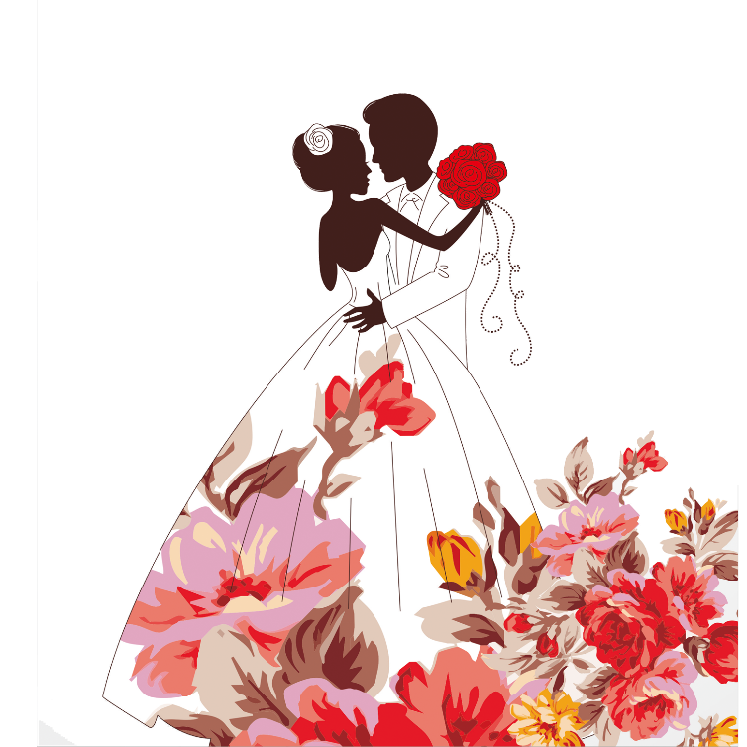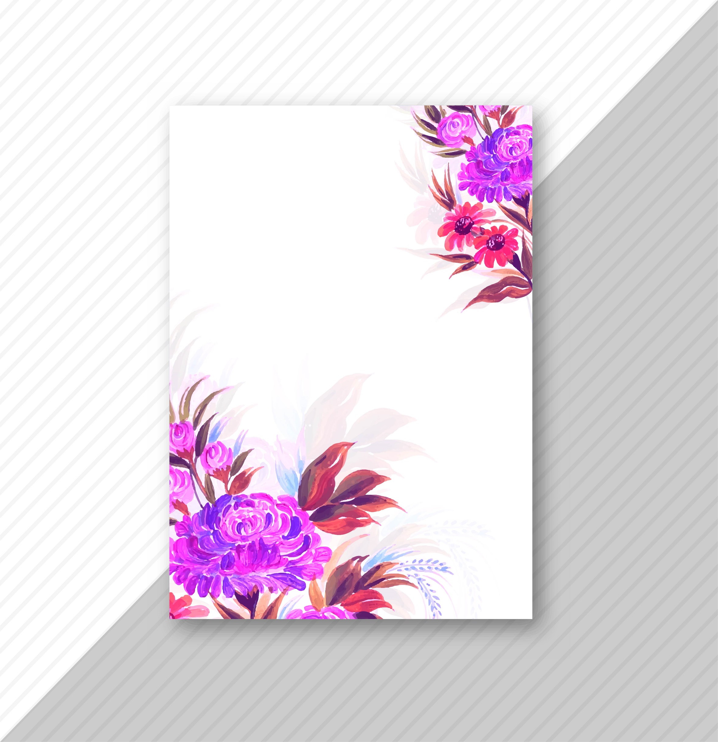

**Ceremony**

**Wedding Processional – (write here)**

**Welcome & Opening Prayer**

Lorem ipsum dolor sit amet. Et inventore earum qui assumenda quia quo velit quae. Sit sunt blanditiis indoors blanditiis eum nihil sunt ad facilis nisi non ullam perspiciatis repellat sequi ad facilis nihil qui numquam fuga ut magni sequi qui earum mollitia et nihil harum. Aut temporibus quam et perspiciatis consectetur ut numquam laborum sed voluptas laboriosam eos provident fuga. In adipisci ipsum est fugit quasi aut voluptas sint.

Lauren & Branson

SATURDAY . THE TWENTY – SECOND OF JULY

two thousand twenty-three

AT FIVE O’CLOCK IN THE EVENING

ST. PERTER’S CHURCH

Ash Church Road, Ash, Surrey, Gu12 6LU

**THE HONOR OF YOUR PRESENCE**

**is requested at the marriage of**