Sushi Menu o Sushi Restaurant
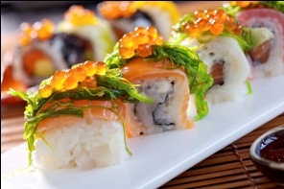

Crunchy Chicken Roll | Crunchy Beef Roll | Menu Item
Chicken, Cucumber, Mayonnaise, Teriyaki Sauce | Beef, Cucumber, Mayonnaise, Teriyaki Sauce | Menu Description
Price
Crunchy Chicken Roll | Crunchy Beef Roll | Menu Item
Chicken, Cucumber, Mayonnaise, Teriyaki Sauce | Beef, Cucumber, Mayonnaise, Teriyaki Sauce | Menu Description
Price
Crunchy Chicken Roll | Crunchy Beef Roll | Menu Item
Chicken, Cucumber, Mayonnaise, Teriyaki Sauce | Beef, Cucumber, Mayonnaise, Teriyaki Sauce | Menu Description
Price

Sushi Menu o Sushi Restaurant
Crunchy Chicken Roll | Crunchy Beef Roll | Menu Item
Chicken, Cucumber, Mayonnaise, Teriyaki Sauce | Beef, Cucumber, Mayonnaise, Teriyaki Sauce | Menu Description
Price
Crunchy Chicken Roll | Crunchy Beef Roll | Menu Item
Chicken, Cucumber, Mayonnaise, Teriyaki Sauce | Beef, Cucumber, Mayonnaise, Teriyaki Sauce | Menu Description
Price
Crunchy Chicken Roll | Crunchy Beef Roll | Menu Item
Chicken, Cucumber, Mayonnaise, Teriyaki Sauce | Beef, Cucumber, Mayonnaise, Teriyaki Sauce | Menu Description
Price

