
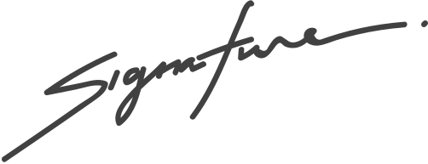

Henrietta Mitchell
is a female rabbit born on August 8th, 2021
to parents, David and Anna.
BIRTH CERTIFICATE
RABBIT NAME
This certifies that
Pet shop manager

