
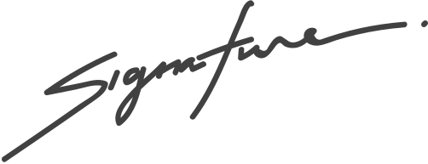

BIRTH CERTIFICATE
PUG NAME
Juliana Silva
Pet shop manager
This certifies that
is a male pug born on August 8th, 2021
to parents, David and Anna.

