
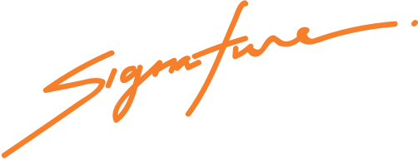
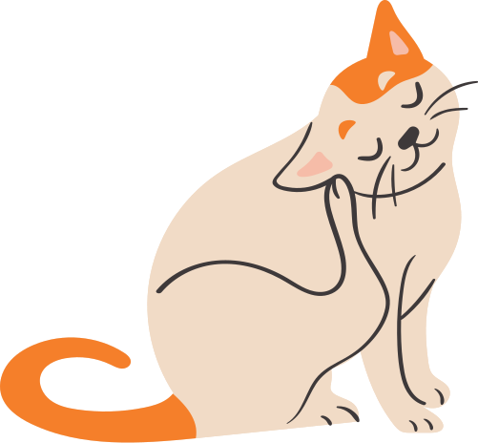
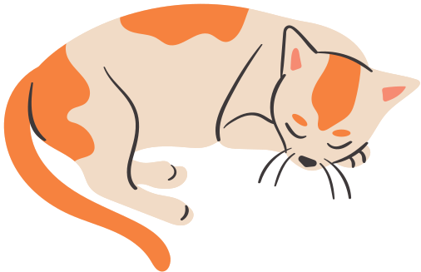
John Smith
PET SHOP MANAGER
This certifies that
kitten name
Birth Certificate
is a female kitten born on August 8th, 2021
to parents, David and Anna.

