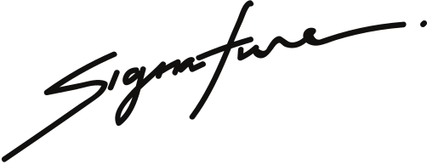



CHRISTINA SHERLY
Pet shop manager
guinea pig NAME
This certifies that
Birth Certificate
is a male guinea pig born on August 8th, 2021
to parents, David and Anna.

