Construction Professionals Indemnity Proposal Form

|  |
| --- |
| **AN IMPORTANT NOTICE TO THE APPLICANT - ‘CLAIMS MADE’ CONTRACTS OF INSURANCE** |
| **PLEASE READ AND RETAIN IN YOUR FILE** |
| The proposed insurance is issued on a ‘claims made’ basis. This means that the policy responds to: -  ➊ Claims first made against the insured during the policy period and notified to Procover Underwriting Agency Pty Ltd during that policy period, providing that the insured was not aware, at any time prior to the policy inception, of circumstances which would have alerted a reasonable person in the insured’s position that a claim may be made against the insured; and  ➋ ‘Claims circumstances’ notified pursuant to Section 40 (3) of the Insurance Contracts Act which states:  *‘Where the insured gave notice in writing to the insurer of facts that might give rise to a claim against the insured as soon as was reasonable practicable after the insured became aware of those facts but before the insurance cover provided by the contract expired, the insurer is not relieved of liability under the contract in respect of the claim, when made, by reason only that it was made after the expiration of the period of insurance cover provide by the contract’*  After policy expiry, no new claims can be made on the expired policy even though the event giving rise to the claim may have occurred during the policy period.  If during the policy period you become aware of circumstances which a reasonable person in your position would consider may give rise to a claim, and which you fail to notify us during the policy period, we may not cover you under a subsequent policy for any claim which arises from these circumstances.  When completing the proposal you are obliged to report and provide full details of all circumstances of which you are aware and which a reasonable person in your position would consider may give rise to a claim.  It is important that you make proper disclosure (see Duty of Disclosure, below) so that your cover under any new policy with us is not compromised.  Pursuant to the Insurance Contracts Act 1984 your duty to disclose all relevant information is set out below. |
| **YOUR DUTY OF DISCLOSURE: -** |
| Before you enter into a contract of insurance with an insurer, you have a duty, under the Insurance Contracts Act 1984, to disclose to the insurer every matter that you know, or could reasonably be expected to know, is relevant to the insurer’s decision whether to accept the risk, and, if so, on what terms.  You have the same duty to disclose those matters to the insurer before you renew, extend, vary or reinstate a contract of insurance.  Your duty however, does not require the disclosure of matters:   * that diminishes the risk to be undertaken * that is of common knowledge * that your insurer knows, or in the ordinary course of his/her business, ought to know * as to which compliance with your duty is waived by the insurer   Please note: Your duty of disclosure continues after the proposal form has been completed until the policy is entered into - i.e. until the date we receive instructions to bind cover.  Furthermore, please note that information contained in your website is not considered to satisfy your duty of disclosure and all material facts regarding the risk should be disclosed in the proposal form. |
| **NON-DISCLOSURE** |
| If you fail to comply with your duty of disclosure, the insurer may be entitled to reduce liability under the contract in respect of a claim or may cancel the contract. If your non-disclosure is fraudulent, the insurer may also have the option of avoiding the contract from its beginning. |

|  |  |
| --- | --- |
| PRIVACY |  |
|  | Lloyd’s and its agent are bound by the obligations of the Privacy Act 1988 as amended by the Privacy Amendment (Private Sector) Act 2000 (the Act). This sets out the basic standards relating to the collection, use, disclosure and handling of personal information.  Personal Information is essentially information or an opinion about a living individual whose identity is apparent or can reasonably be ascertained from the information or opinion. Information will be obtained from individuals directly where possible. Sometimes it may be collected indirectly. Only information necessary for the arrangement and administration of Lloyd’s business by Lloyd’s, its agents and their representatives will be collected. This includes information necessary to accept the risk, to assess a claim, to determine competitive and appropriate premiums.  Lloyd’s and its agents disclose personal information to third parties who they believe are necessary to assist them in doing. These parties will only use the personal information for the purposes we provided it to them for (or if required by law).  When you give Lloyd’s and its agents personal information about other individuals, we rely on you to have made or make them aware that you will or may provide their personal information to us, the types of third parties we may provide it to, the relevant purposes we and the third parties we disclose it to will use it for, and how they can access it. If it is sensitive information we rely on you to have obtained their consent on these matters. If you have not done or will not do either of these things, you must tell us before you provide the relevant information.  You are entitled to access your information if you wish and request correction if required. You may also opt out of receiving materials sent by Lloyd’s by contacting Procover Underwriting Agency Pty Ltd on 02 9307 6600.  Contact details for Procover Underwriting Agency are:  Procover Underwriting Agency Pty Ltd  Level 5, 97-99 Bathurst Street, Sydney NSW 2000  Phone +61 2 9307 6600  Fax +61 2 9307 6699 |
| RETROACTIVE LIABILITY |  |
|  | The proposed insurance may be limited by a retroactive date either stated in the schedule or endorsed onto the policy. Where the retroactive cover by the proposed policy is subject to such date, then the policy does not cover any claim arising from any actual or alleged act, error, omission or conduct occurring prior to such retroactive date. |
| KEY FACTORS |  |
|  | These questions reflect the key factors that are taken into account when determining your premium. |
| For Your Information |  |
| ➊ | Answer all questions. Blanks &/or dashes, or answers ‘known to underwriters or brokers’ or ‘N/A’ are not acceptable & will delay consideration of this proposal. |
| ➋ | If there is insufficient room to complete a question, please attach a signed & dated addendum. |
| ➌ | Any documents attached to the proposal form are part of the proposal. |
| ➍ | Where appropriate, please tick the yes or no box that best indicates your reply. |
| ➎ | To qualify for additional premium discounts, please submit all requested additional information as per page 12. |

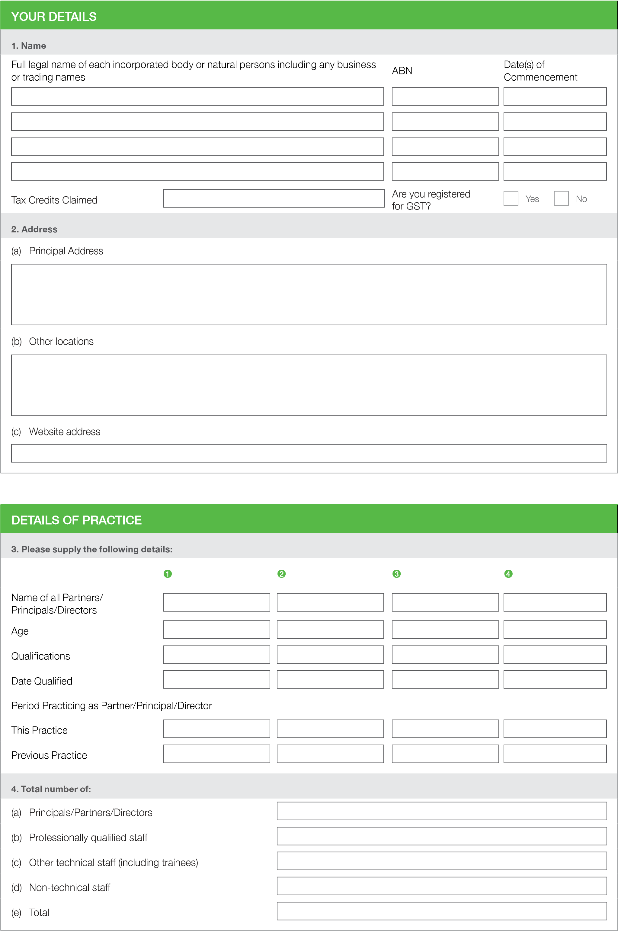

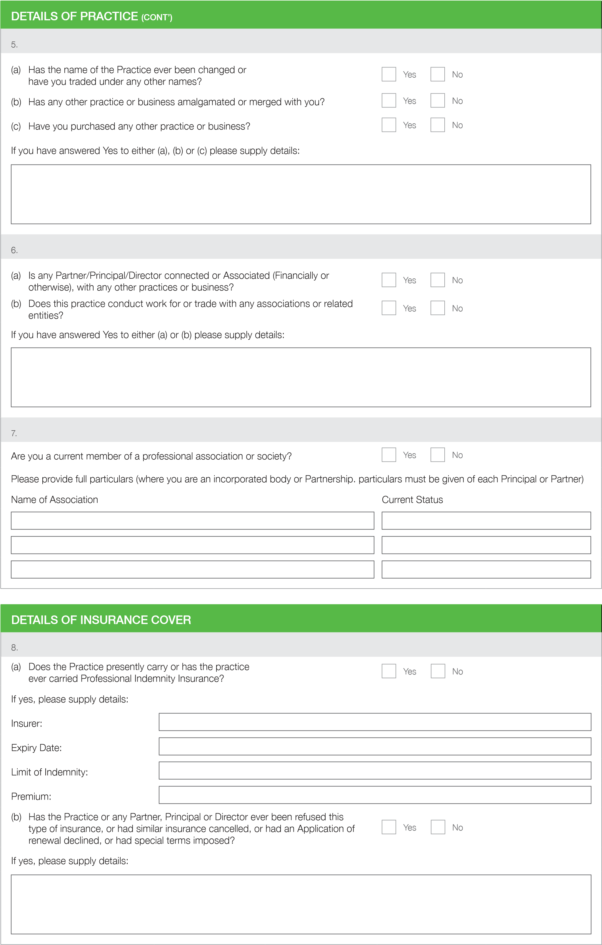

|  |  |  |  |  |  |
| --- | --- | --- | --- | --- | --- |
| **YOUR PROFESSIONAL ACTIVITIES** | | | | | |
| **9. Nature of your Business** | | | | | |
| **(a) State fully the nature of your business (Please provide copies of any brochures or other documentation which may assist the insurer in gaining a better appreciation of the risk being proposed).** | | | | | |
|  | | | | | |
| **(b) Please express as a percentage of your gross professional fees stated in question 18, your revenue derived from the following fields of activity. (If no actual fees, answer in relation to estimated fees)** | | | | | |
| 1. S tructural Engineering 2. Geotechnical Engineering 3. M echanical Engineering 4. E lectrical Engineering 5. C ivil Engineering 6. Chemical Engineering 7. Construction and/or Project   Management   1. Town Planning | % | 1. S urveying 2. A rchitecture 3. Other (please specify): | i) Land ii) Q uantity iii) B uilding | % |  |
| |  | | --- | | % | | % | | % | | % | | % | | % | | % | | |  | | --- | | % | | % | | % | | % | | % | |
| **(c) To enable Us to better appreciate the type of work You do or have been involved in, please state as an approximate percentage of your gross professional fees** | | | | | |
| 1. Domestic/Residential Buildings  |  | | --- | | % |  |  | | --- | | % |   (l) Oil & Pipelines  (up to 3 floors)   |  |  |  | | --- | --- | --- | | % | (m) Refineries | % |  1. Commercial Buildings (including townhouses and flats over 3 floors)  |  |  |  | | --- | --- | --- | | % | (n) Mechanical & Bulk Handling Equipment | % |  1. Institutional Buildings  |  |  |  | | --- | --- | --- | | % | (o) Fair Grounds and Exhibitions | % |  1. Industrial Buildings 2. High Rise Buildings  |  |  |  | | --- | --- | --- | | % | (p) Subsurface Surveys, Ground & Soil | % |   (not other wise classified) Testing   |  |  |  | | --- | --- | --- | | % | (q) Land Reclamation/Remediation | % |  1. Town Planning  |  |  |  | | --- | --- | --- | | % | (r) Retaining Wall | % |  1. Marine  |  | | --- | | % |  1. Bridges(s) Other (please specify)  |  |  |  |  |  | | --- | --- | --- | --- | --- | | |  | | --- | | % | |  | |  | | --- | | % | | | |  | | --- | | % | | |  | | --- | | % | |  1. Tunnels 2. Dams  |  | | --- | | % |  1. Mines | | | | | |
| **(d) Are verbal reports or advice always confirmed in writing?**  No    Yes | | | | | |
| |  | | --- | | % |   Please give details of what approximate percentage of reports have been given in the last 12 months as verbal reports only | | | | | |
| **(e) Are written disclaimers included with advice being given?**  No    Yes | | | | | |
| If Yes, please provide an example | | | | | |

|  |  |
| --- | --- |
| PROCOVER UNDERWRITING AGENCY PTY LTD | CONSTRUCTION PROFESSIONALS INDEMNITY PROPOSAL FORM | AFSL: 314 176 ABN: 46 165 322 592 |

|  |  |  |  |  |
| --- | --- | --- | --- | --- |
| **YOUR PROFESSIONAL ACTIVITIES (CONT’)** |  | | | |
| 10. |  | | | |
| Do you envisage any substantial changes in your activities or are there any major new operations being contemplated during the next 12 months?  If Yes, please provide an example | No    Yes | | | |
| 11. Are you or have you any parent, subsidiary or other related entity: |  | | | |
| 1. engaged in or; 2. have had a controlling share of an entity engaged in:   (a) Actual construction, fabrication, erection or any form of contracting? | No    Yes | | | |
| (b) Real estate development? | No    Yes | | | |
| (c) The manufacture, sale or distribution of any product or process or patented production process?  If Yes, please provide details:   1. Names of the other entities involved, outlining their relationship to you 2. Full details, including a description of the nature of the involvement | No    Yes | | | |
| 12. Consultants, Sub-consultants and Agents |  | | | |
| Do you engage consultants, sub-contractors or agents?  If Yes,  (a) Do you insist they carry their own Professional Indemnity Insurance? |  | Yes  Yes |  | No  No |
|  |  |
| (b) Are there minimum sums insured that you require? | No    Yes | | | |
| (c) Do you enter into any hold-harmless agreements or otherwise waive any Legal rights or entitlements which you may have against consultants, sub-contractors or agents?  If you have answered Yes to either (a), (b) or (c) please supply details: | No    Yes | | | |
| 13. Specific Project Policies |  | | | |
| Have you ever undertaken work in respect of which with the potential professional liability arising there from has been or is protected by a specific project insurance policy?  Please provide details: | No    Yes | | | |
| 14. Work (Outside Australia/New Zealand) |  | | | |
| Do you perform work outside of Australia, or work for clients located overseas?  If Yes, please provide details: | No    Yes | | | |

|  |
| --- |
| **YOUR PROFESSIONAL ACTIVITIES (CONT’)** |
| **15. Miscellaneous** |
| Does any one client (or group of companies) account for more than 50% of your income? No    Yes    If Yes, in respect of each such client, state the approximate percentage of your income derived from that client or group of companies. Also explain your relationship with that client and the nature of the work you perform for them.  Please attach information to a separate sheet of paper if required. |
| **16. For Sole Traders only** |
| What arrangements do you have to cover the business or practice during your temporary absence while away on business, sick leave, etc? |
| **17. Risk Management** |
| (a) D o you have a document Risk Management Program (Consistent with Australian Standards AS/NZS 4360:1999) which address your professional duty of risk?    Please provide a copy    Yes      No  b)  (  What date was the program implemented?  c)  (  Is the program independently reviewed/monitored/audited?    Yes      No  If Yes, please provide details:  (  d) W hen was that program last reviewed and updated to ensure it  complies with the current standards applying to your profession?  (  e)  Is there a principal/director/partner responsible for overseeing risk management within your practice?    Yes      No  If Yes, please provide details: |
|  |
| **FEE INCOME** |
| **18.** |
| 1. P lease state your Gross Professional Fees over the periods stated. Include fees paid to sub-consultants appointed by you. Exclude fees collected for disbursement to Consultants appointed by your client together with traveling accommodation or similar expenses reimbursed by your clients.   Australia Overseas  Estimated Current Year  Prior Financial Year  Previous Financial Year   1. Please provide a percentage breakdown of the fee income disclosed in Question 18 (a) by State or   Territory  NSW VIC QLD SA WA TAS NT ACT O’Seas **TOTAL**   |  |  |  |  |  |  |  |  |  |  |  |  |  |  |  |  |  |  |  | | --- | --- | --- | --- | --- | --- | --- | --- | --- | --- | --- | --- | --- | --- | --- | --- | --- | --- | --- | | % |  | % |  | % |  | % |  | % |  | % |  | % |  | % |  | % |  | % | |

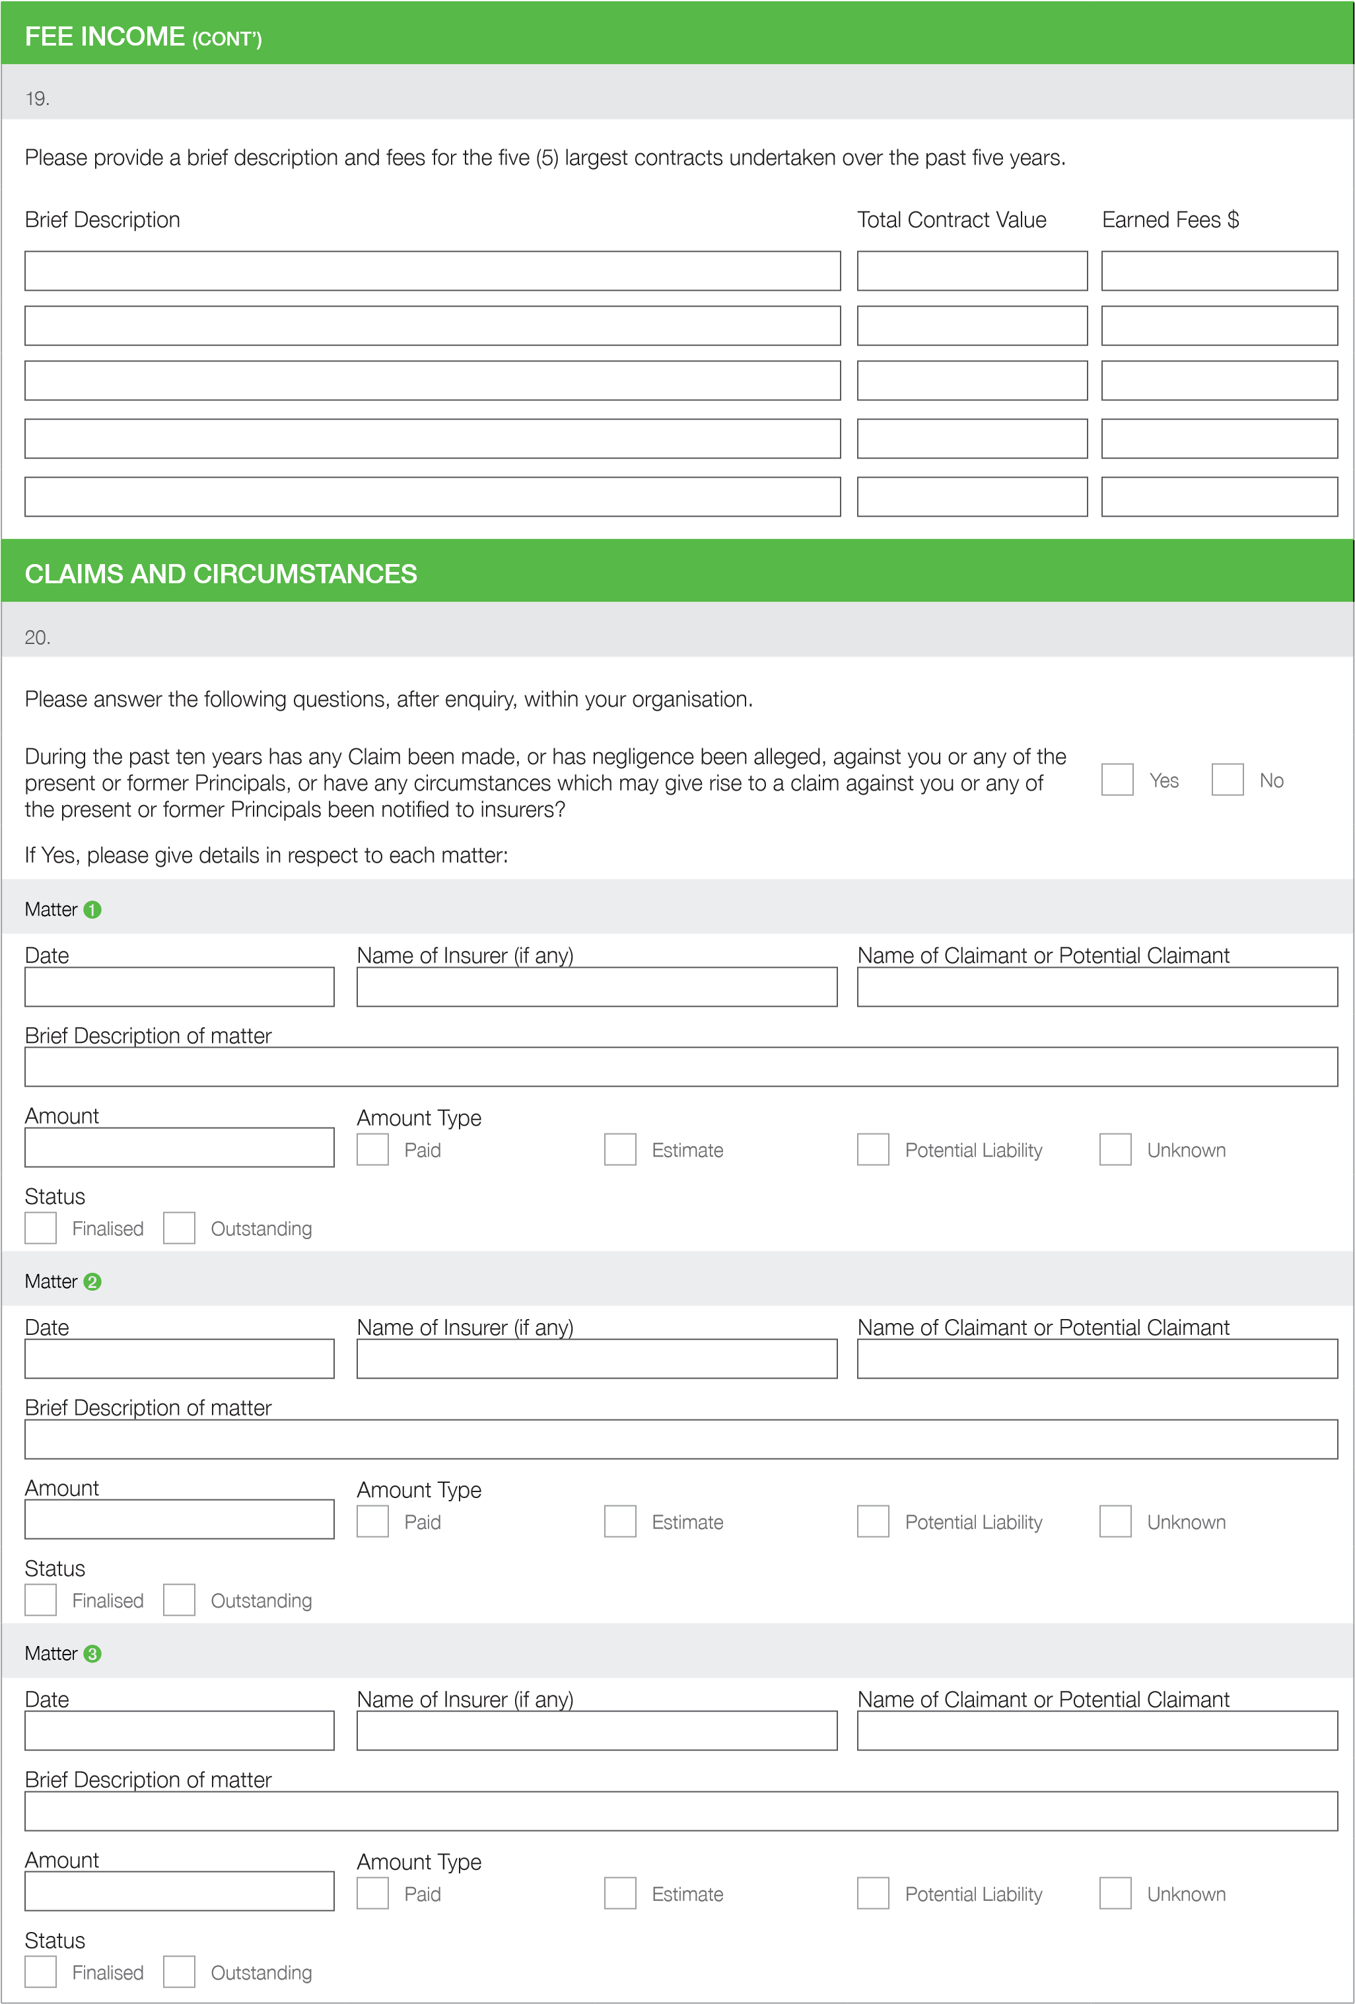

|  |  |  |  |  |  |  |  |
| --- | --- | --- | --- | --- | --- | --- | --- |
| **CLAIMS AND CIRCUMSTANCES (CONT’)** | | | | | | | |
| **21.** | | | | | | | |
| Are there any Partners Principals or Directors, after enquiry, aware of any Claim or has negligence been alleged,    Yes    against you or any of the present or former Principals, or have any circumstances which may give rise to a claim No against you or any of the present or former Principals which has not been referred to in the previous question?  If Yes, please give details in respect to each matter: | | | | | | | |
| **Principals / Partners Matter** ➊ | | | | | | | |
| Name of claimant or potential claimant Estimate of potential liability  Brief Description of matter | | | | | | | |
|  |  | | | | | |  |
| **Principals / Partners Matter** ➋ | | | | | | | |
| Name of claimant or potential claimant Estimate of potential liability  Brief Description of matter | | | | | | | |
|  |  | | | | | |  |
| **Principals / Partners Matter** ➌ | | | | | | | |
| Name of claimant or potential claimant Estimate of potential liability  Brief Description of matter | | | | | | | |
|  |  | | | | | |  |
| **22.** | | | | | | | |
| Has any Principal or staff member ever been subject to disciplinary proceedings for Professional Misconduct?  If Yes, please give details in respect to each matter:  Are any of the principals, partners or directors aware, after enquiry of all staff, managers and contractors, of any accounts overdue for payment where there is reason to believe that the client is dissatisfied with the professional services rendered?  If Yes, please provide details: | | |  | Yes  Yes |  | No  No | |
|  |  |
| **23. Have your or any partner(s) shareholder(s) or director(s) of the business:** | | | | | | | |
| 1. Ever been declared bankrupt? 2. Ever been involved in a company or business which became insolvent or subject to any form of insolvency administration (e.g. liquidation or receivership)? 3. Been convicted of any criminal offence within the past 5 years (other than minor traffic convictions)? 4. Been liable for any civil offence or pecuniary penalty (exceeding $5,000)? 5. Any other matters you should disclose?   If Yes to any of the above, please supply details: | | |  | Yes  Yes  Yes  Yes  Yes |  | No  No  No  No  No | |
|  |  |
| **COVER REQUIRED** | | | | | | | |
| **24.** | | | | | | | |
| Please state: | | | | | | | |
| 1. A mount of preferred Total Sum Insured 2. A mount of preferred excess | | $ | | | | |  |
| $ | | | | |
| (N.B.) Your policy will be subject to a minimum excess | | | | | | | |

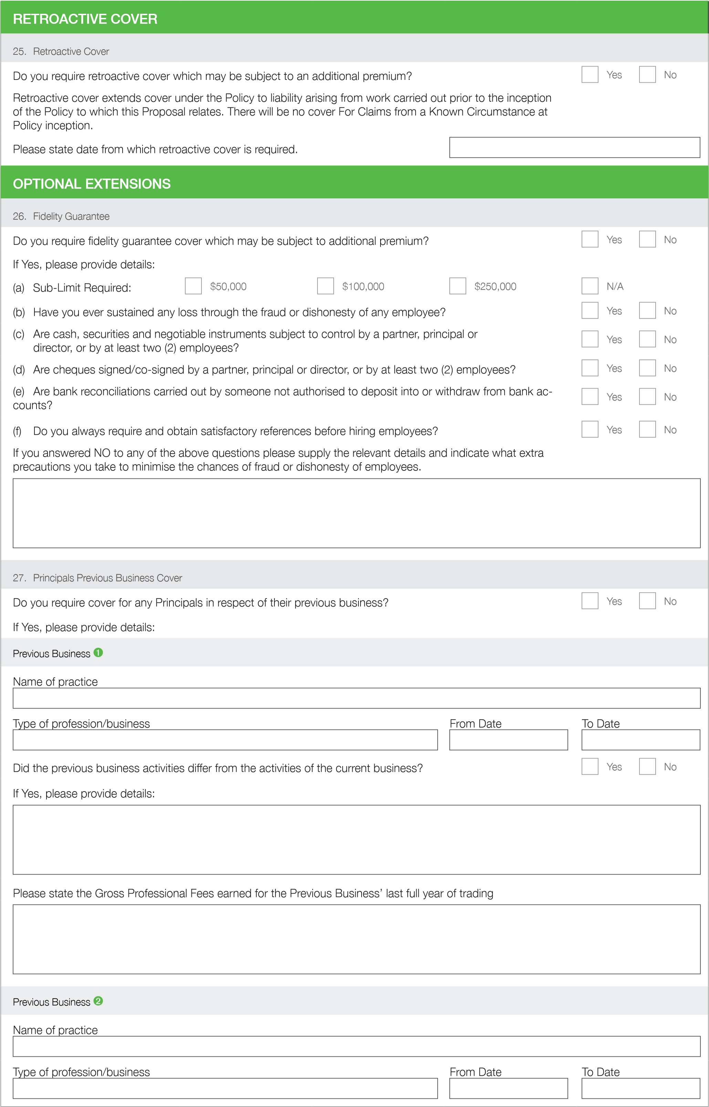

**OPTIONAL EXTENSIONS**

**)**

**CONT’**

**(**

**.**

**27**

**Principals Previous Business Cover**

Did the previous business activities differ from the activities of the current business?

Yes

No

If Yes, please provide details:

Please state the Gross Professional Fees earned for the Previous Business’ last full year of trading

**Previous Business**

➌

Name of practice

Type of profession/business

From Date

To Date

Did the previous business activities differ from the activities of the current business?

Yes

No

If Yes, please provide details:

Please state the Gross Professional Fees earned for the Previous Business’ last full year of trading

These questions reflect the key factors that are taken into account when determining your premium.

|  |  |
| --- | --- |
| **I/WE HEREBY DECLARE THAT:** | |
| My/Our attention has been drawn to the Important Notice at the beginning of this Proposal form and further I/We have read these notices carefully and acknowledge my/our understanding of their content by my/our signature/s below.  The above statements are true, and I/we have not suppressed or mis-stated any facts and should any information given by me/us alter between the date of this Proposal form and the inception date of the insurance to which this Proposal relates I/we shall give immediately notice thereof.  I/We authorize Procover Underwriting Agency Pty Ltd, to collect or disclose any personal information relating to this insurance to/from any insurers or insurance reference service.  I/we have provided information about another individual I/we declare that the individual has been or will be made aware of that fact.  I/we also confirm that the undersigned is/are authorized to act for and on behalf of all persons who may be entitled to indemnity under any policy which may be issued pursuant to this Proposal form, and I/we complete this Proposal form on their behalf.  To be signed by the Chairman/President/Managing Partner/Managing Director/ Principal of the association/Partnership/Company/Practice/Business. | |
|  | |
| Applicant ➊  **NAME**     |  | | --- | | X |   **SIGNATURE** |  |
| **TITLE** |
|  |
| **DATE** (DD/MM/YY) |
|  | |
| Applicant ➋  **NAME**     |  | | --- | | X |   **SIGNATURE** |  |
| **TITLE** |
|  |
| **DATE** (DD/MM/YY) |
| It is important the signatory/signatories to the Declaration is/are fully aware of the scope of this insurance so that all questions can be answered. If in doubt, please contact your insurance broker since non-disclosure may affect an Insured’s right of recovery under the policy or lead to the policy being voided. | |
| **REQUIRED ATTACHMENTS** | |
| The following documentation must be attached to this Proposal in order for your application to be considered for full premium discounts available:  ➊ CV or resume for each Partner/Principal/Director/Senior professionally qualified staff  ➋ Copies of all brochures and promotional material  ➌ Copies of all Disclaimers  ➍ Copies of Risk Management procedures  ➎ Full details of all Claims Notifications  ➏ Standard Contract Terms and Conditions (or Service Agreements) identifying areas of Liability Limitations or Waiver of any rights | |