



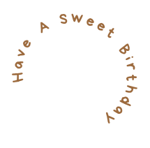
HAPPY
BIRTHDAY!
Birthdays are a new start,
a fresh beginning and
a time to pursue new endeavors with new goals. Move forward with confidence and courage. You are a very special person. May today and all of your days be amazing!
- From Anna -

