
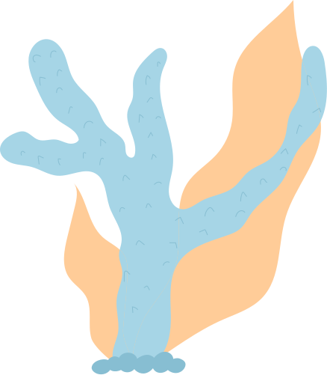

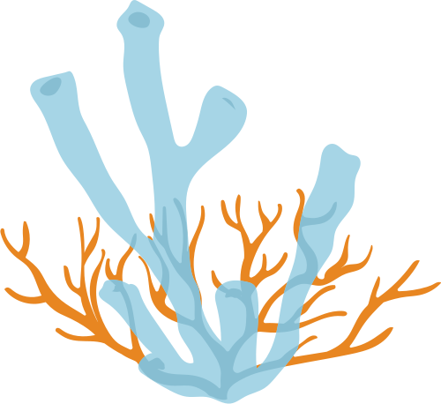

is a baby fish born on August 8th, 2021
to parents, David and Anna.
This certificate is presented to
FISH NAME
BIRTH CERTIFICATE
Mr. Richard edisson
PET SHOP MANAGER

