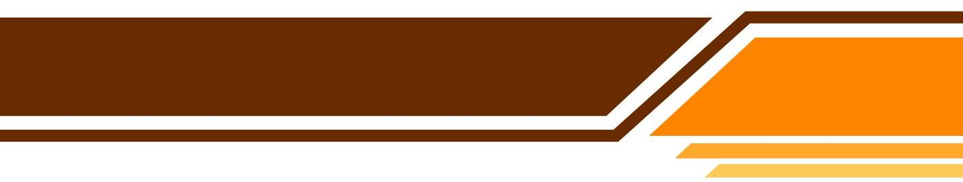**Family Loan Agreement**

**Promise to Pay**

For value received, _______________________, (the ‘Borrower’) promises to pay __________________________ (the ‘Lender’) $__________ and interest at the yearly rate of ______% on the unpaid balance as specified below.

**Monthly Installments**

Borrower will pay ____ monthly installments of $_______ each.

**Date of Installment Payments**.

Borrower will make an installment payment on the ____the day of each month beginning ____________, 20___ until the principal and interest have been paid in full.

**Application of Payments**.

Payments will be applied first to interest and then to principal.

**Prepayment**.

Borrower may prepay all or any part of the principal without penalty.

**Loan Acceleration**.

If Borrower is more than ____ days late in making any payment, Lender may declare that the entire balance of unpaid principal is due immediately, together with the interest that has accrued.

**Security.**

(There is no security since this is a family loan.)

– – – – – – – – – – – – – – – – – – – – – – – – – – – – – – – – – – – – – – – – – – – – – – –

This agreement was signed and dated on the ____ day of _______________, 20_____

(Signed and dated by both parties; each party receives a signed original)

|  |  |
| --- | --- |
| Borrower  _______________________ | Lender  _______________________ |
| Signature  _______________________ | Signature  _______________________ |
| Witness  _______________________ | Signature  _______________________ |



www.Templateral.com