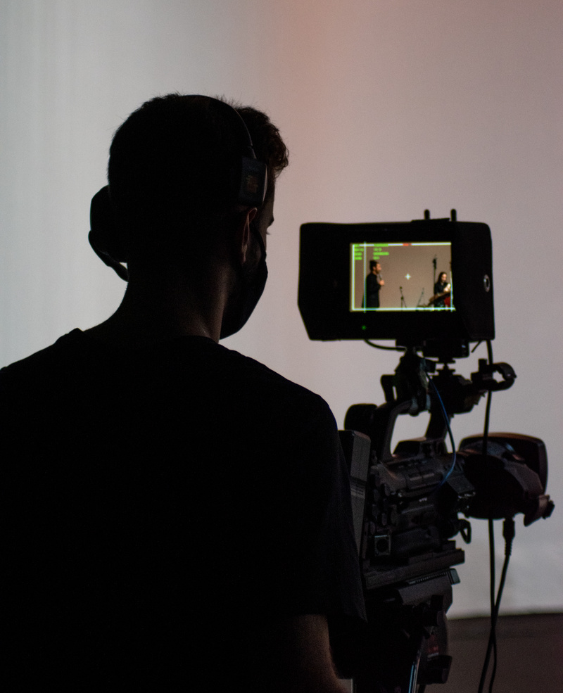
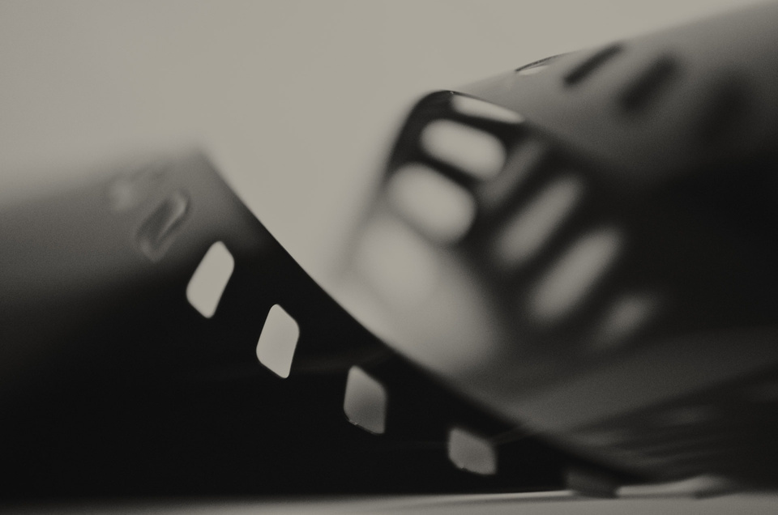
Time
2:00 PM to 7:00 PM
Venue
Silver Screen Studios
EVENT
BOOKLET
SHORT HISTORY OF FILMMAKING
Saturday,
June 17, 2024
CINEFEST
CINEFEST
01
END
40 MINS
Showcase & Closing Remarks
Screen participants' work, discuss learnings, and wrap up the filmmaking workshop
6:20 PM
- 7:00 PM
MAIN CONTENT
60 MINS
Basics of Storyboarding
Learn the art of visual storytelling by translating a script into storyboards
2:35 PM
- 3:35 PM
90 MINS
Lights, Camera, Action!
Hands-on session covering camera usage, framing, and capturing dynamic scenes
3:35 PM
- 5:05 PM
75 MINS
Editing Essentials
Dive into the world of editing, mastering
the basics to enhance your films
5:05 PM
- 6:20 PM
OPEN
20 MINS
Icebreaker: Filmmaking Bingo
Break the ice and ignite creativity with
a fun filmmaking-themed bingo game
2:15 PM
- 2:35 PM
15 MINS
Welcome & Introduction
Get acquainted, overview of the
workshop, and set the creative tone
2:00 PM
- 2:15 PM
Schedule
Time
2:00 PM to
7:00 PM
Date
Saturday,
June 17, 2024
Venue
Silver Screen Studios
Dear
Welcome to CineFest, an ode to the magic of filmmaking! Your presence amplifies the thrill of this cinematic exploration. As we embark on this journey of storytelling through film, your passion enriches our shared experience. Thank you for being part of this extraordinary gathering, your enthusiasm elevates the event.
Get ready to immerse yourself in the captivating world of filmmaking where every frame tells a story and
every story sparks imagination. Let the cinematic adventure begin!
CINEFEST
CINEFEST
02


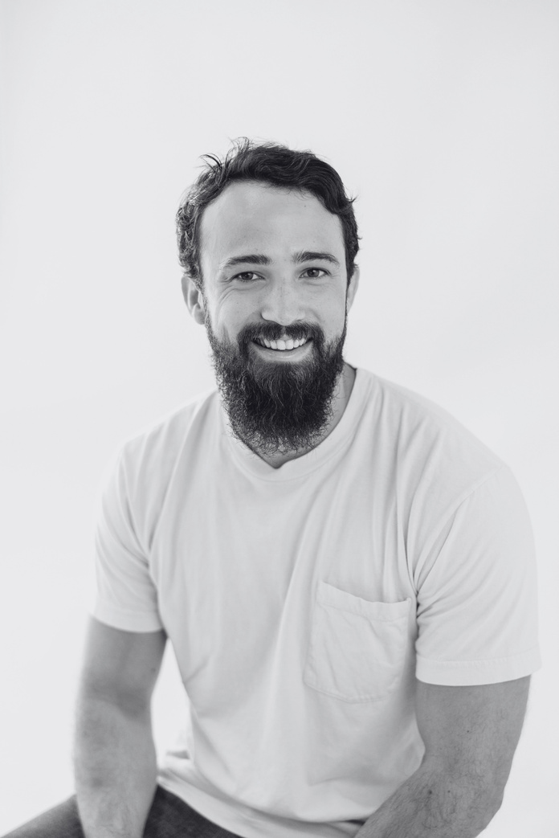
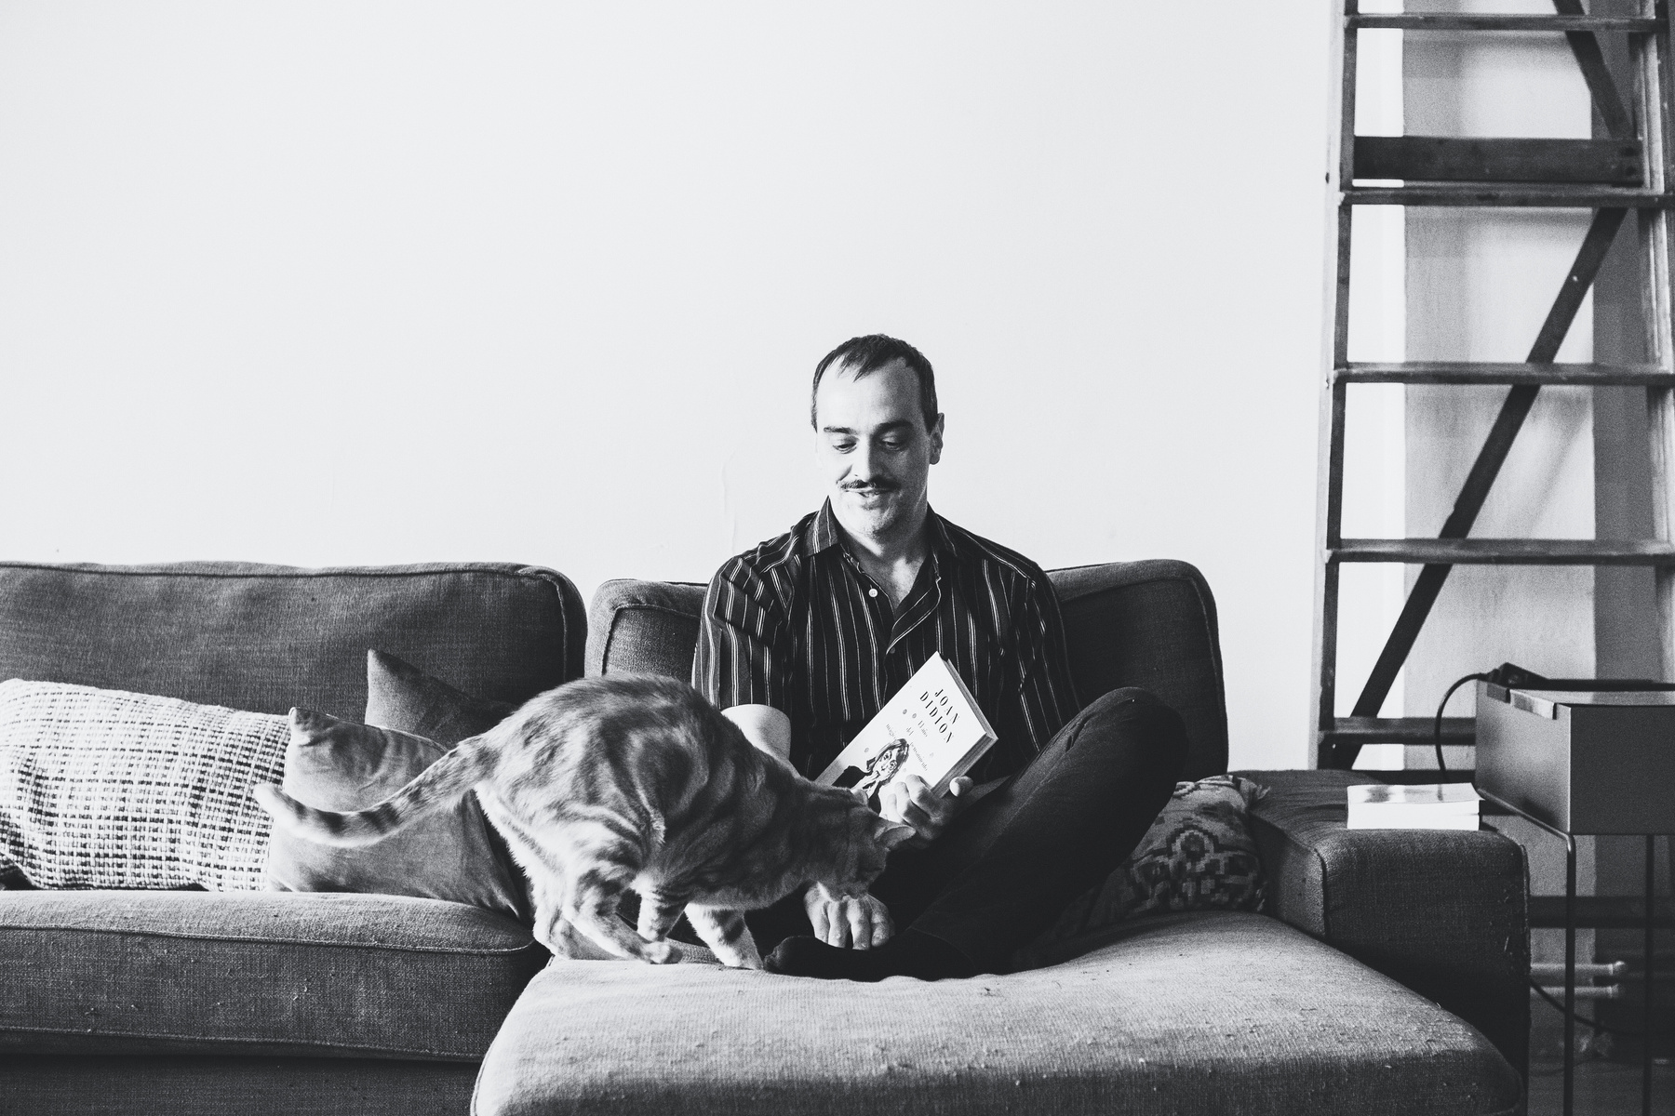
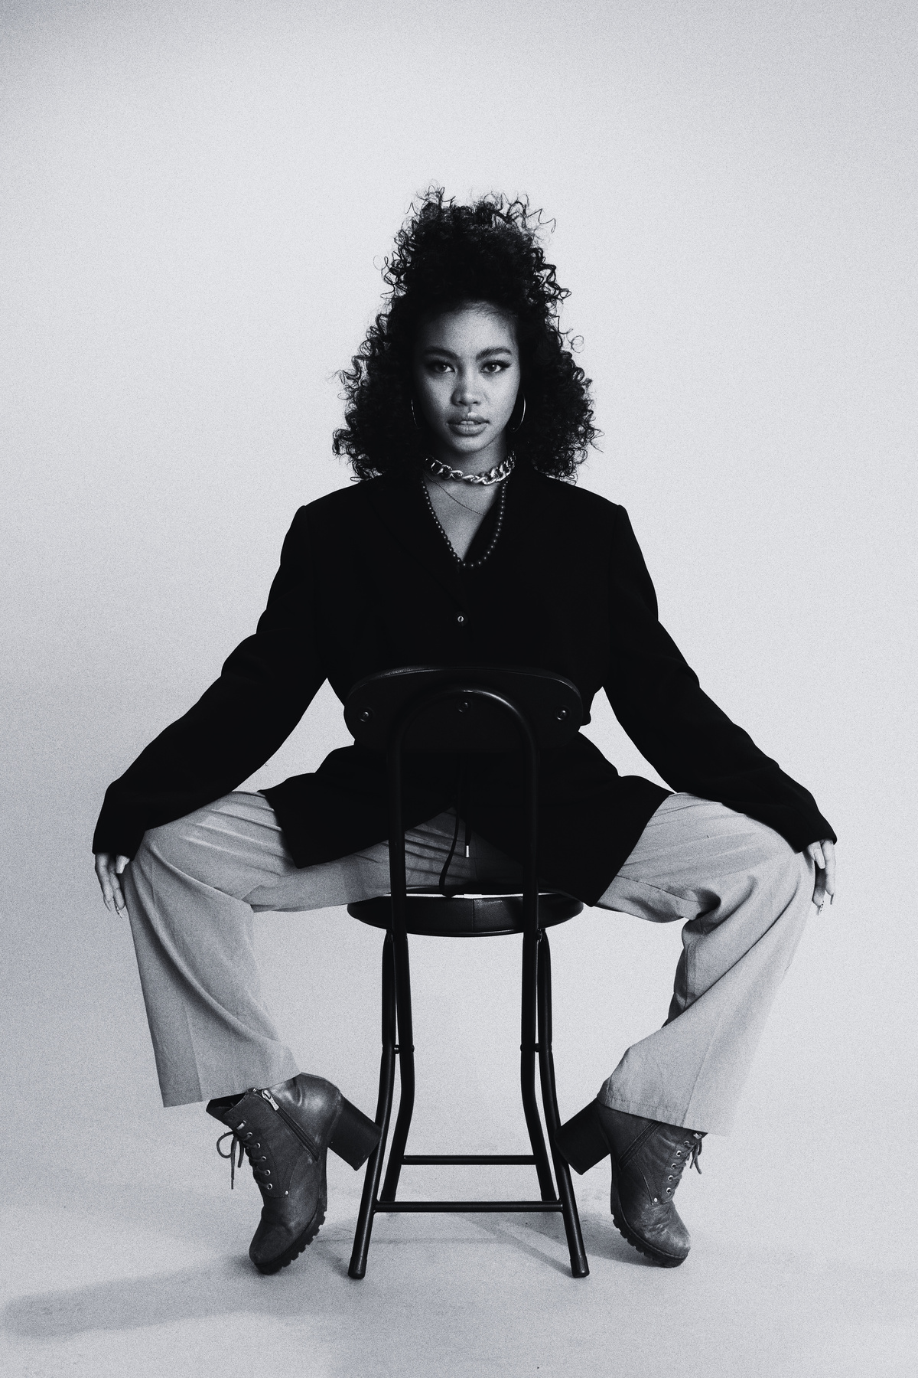
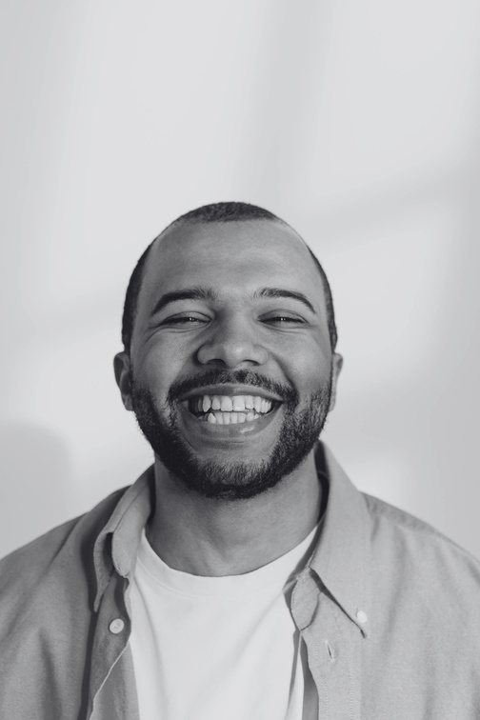
Lucas Chang
Script Continuity Supervisor
(Script Supervisor)
Olivia Bennett
Costume and
Apparel Stylist
(Costume Designer)
Alex Turner
Director of Cinematography (Cinematographer)
Ryan Mitchell
Audio Post
Production Engineer (Sound Mixer)
Emily Thompson
Artistic Production Coordinator
(Production Designer)
Jordan Williams
Motion Picture
Editing Specialist
(Film Editor)
MEET OUR
SPEAKERS
CINEFEST
CINEFEST
03
CINECRAFT SOLUTIONS
Equipment Rental
High-end cameras, lighting, and sound gear for an immersive and professional filmmaking experience
SCRIPTSYNC STUDIOS
Screenwriting Masterclass
Industry experts guide aspiring filmmakers in crafting compelling narratives and engaging screenplays
CINESOUND SOLUTIONS
Audio Mastery
CineSound provides top-notch audio support, ensuring immersive experiences in filmmaking workshops
POSTPRO INSIGHT
Post-Production Lab
Editing software, color grading, and sound design tools for a polished cinematic masterpiece
ACTORS AVENUE AGENCY
Acting Workshop
Professional actors share insights and techniques, helping participants bring characters to life on screen
SPOTLIGHT STRATEGIES
Marketing Mastery
Spotlight Strategies brings creations to the forefront with expert marketing support for workshops
THANK YOU TO OUR VALUED SPONSORS AND PARTNERS
Your support ignited creativity at Cinefest,
shaping cinematic dreams. With gratitude, we celebrate the sponsors who made our filmmaking workshop a vibrant tapestry of inspiration
SPONSORS
SHORT HISTORY OF FILMMAKING
CINEFEST
CINEFEST
04

