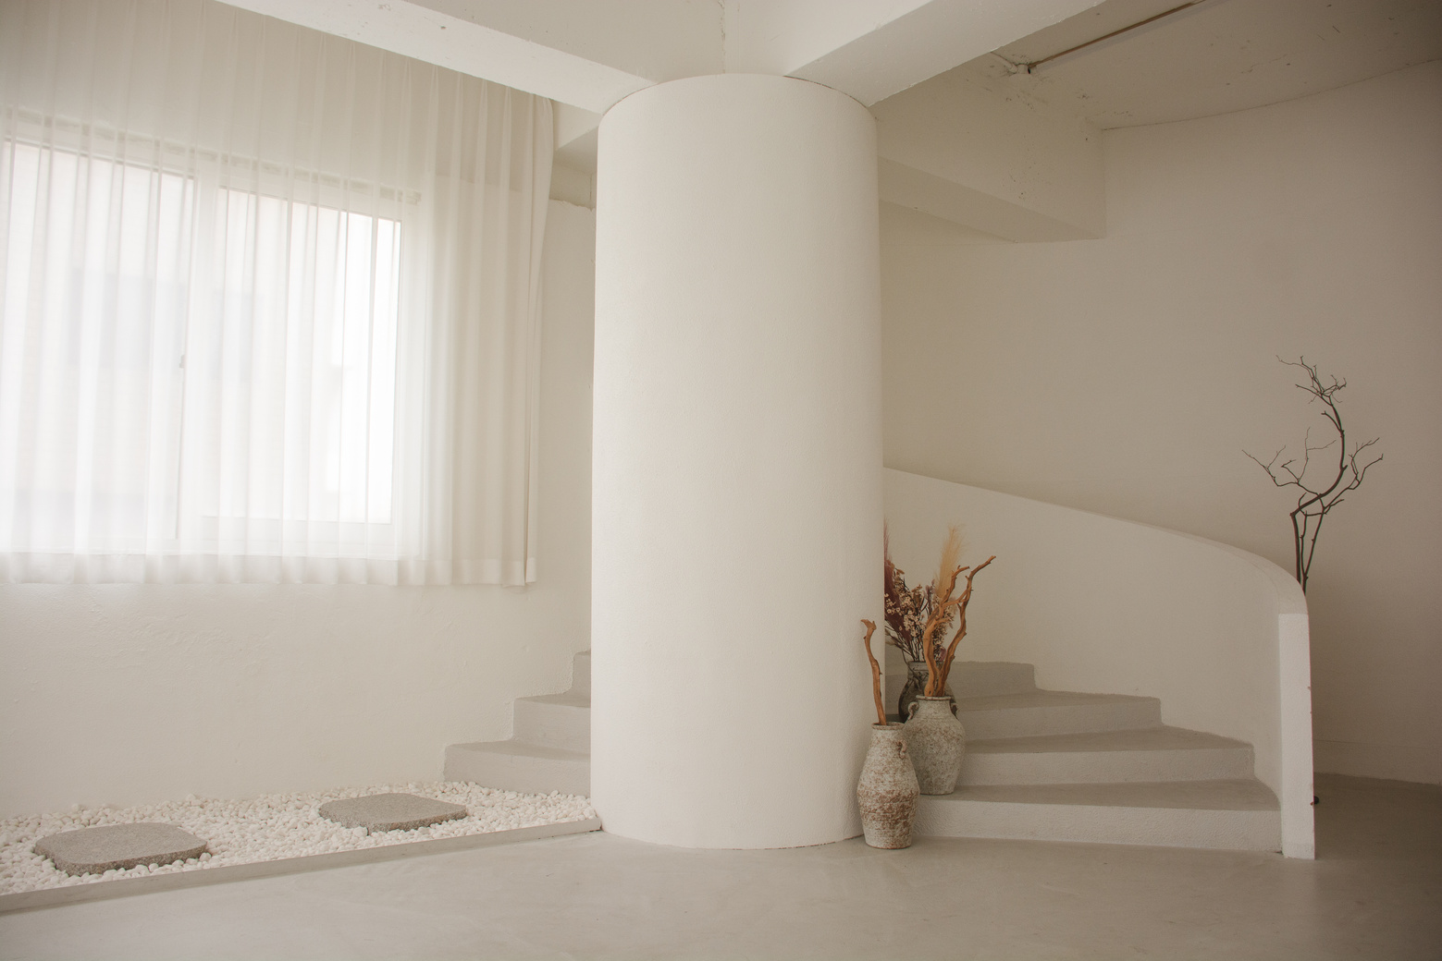
AIR B&B WELCOME BOOKLET
HOME
WELCOME TO OUR
TRANQUILCO
SINCE 2020

WELCOME TO MY HUMBLE PLACE
As the proud owner of this sanctuary, I cherish every moment spent crafting this house into a haven of tranquility. Each detail reflects
my commitment to creating a space where warmth and comfort intertwine seamlessly. From the carefully selected decor to the soothing color palette, every element has been chosen with
intention and care.
My purpose in curating this space extends beyond mere
aesthetics. It is my heartfelt desire to provide you with more
than just accommodation but rather a cozy and healing refuge.
This house is not merely walls and furniture; it's an embodiment
of comfort, designed to nurture your spirit and provide respite
from the outside world. May you find solace in its embrace.
Thank you for choosing my home as your place to stay. Your
decision means the world to me, and I sincerely hope that your time here surpasses expectations. Welcome, and may your stay be filled with moments of serenity and delight.
OWNER TRANQUILICO
ARIA LYNN
MEET THE HOST
TRANQUILCO
AIR B&B WELCOME BOOKLET
Connection name
TranquilCo Official Welcome
Wi-Fi Password
xxx-xxx-xxx-xxx-xxx-xxx-xxx
MAY YOUR SOJOURN BE ABUNDANT WITH TRANQUIL AND JOYOUS INTERLUDES, BRIMMING WITH SERENITY AND DELIGHT, CREATING A TAPESTRY OF CHERISHED MEMORIES
Take a final stroll through the space to ensure no personal belongings are left behind, ensuring a smooth departure
Check-Out Walkthrough
Key and Access Return
Return keys and access cards
to designated spots, concluding your stay responsibly while maintaining security measures
02
25/12
CHECK-OUT TIME: 1PM - 3PM
Appliance Accountability
Confirm that all room appliances are turned off and in their original condition before
leaving the accommodation
Trash Tidiness
Use designated bins for waste disposal, maintaining a tidy space to create a positive, considerate experience for all
Temperature Adjustment
Set the thermostat for comfort, close windows to boost energy efficiency, and honor the host's dedication to a cozy setting
Feedback Farewell
Provide host feedback, emphasize positives, address concerns, maintain open improvement for satisfaction
01
19/12
CHECK-IN TIME: 11AM - 1PM
Room Inspection
Ensure a quick check of the room's condition upon arrival
to identify any existing damages or issues for a smooth stay
Amenity Assessment
Take note of amenities like toiletries, towels, and linens; report shortages promptly
for resolution
Appliance Awareness
Familiarize yourself with room appliances to prevent accidental damage and ensure a hassle-free experience during your stay
Safety Check
Ensure fire extinguishers, smoke detectors, and emergency exits work to prioritize safety during your visit for peace
Cleaning Confirmation
Ensure space cleanliness at check-in, promptly addressing concerns for a comfortable, hygienic environment
Inventory Inspection
Check cutlery, dishes, and entertainment stock to report missing items and ensure a
fully equipped, enjoyable stay
TRANQUILCO
SINCE 2020
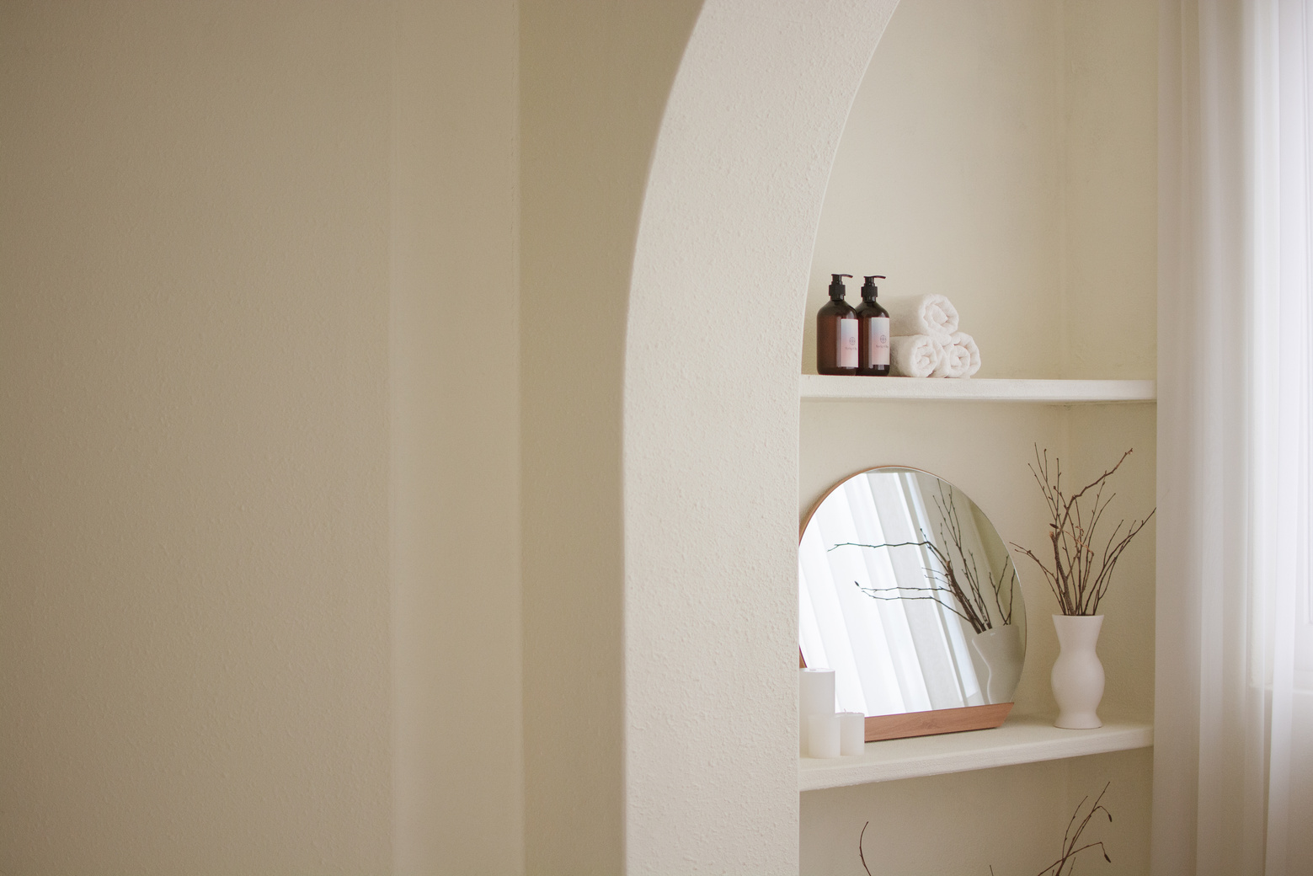
CONTACT
INFORMATION
Your cherished contributions mean the world to us.
Kindly share your experiences to create warmth
Host number - Aria Lynn
+123-456-7890
Website
www.templateLAB.com
Facebook
templateLAB Official
Email
info@templateLAB.com
Address
2 Anywhere Street, Any City
TRANQUILCO
AIR B&B WELCOME BOOKLET

